Special Event Lunch
Order Form:
3 Carne Asada Tacos and Drink $5.00 each

Tuesday, July 5th (4th of July Celebration) ___________ (last day to purchase Thursday, June 30)

Wednesday, July 27 (Halloween in July) ____________ (last day to purchase Thursday, July 21)

Total Paid:________________

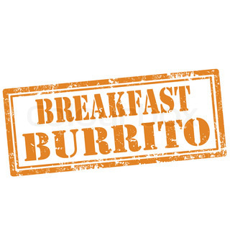
Breakfast Order Form
Egg, Bacon and Sausage Breakfast Burritos
Served at 8am before Field Trips
(Last day to purchase for all 3 dates June 30)
$3.00 each

Friday, July 1 _______________
Friday, July 8 _______________
Friday, July 15 ______________

Total Paid:________________

